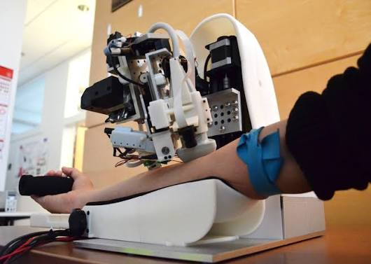
Automated Robotic Venipuncture Simulation and Blood-Draw System

1. Project Idea
The project aims to develop a robotic system capable of detecting artificial veins inside a prosthetic arm, identifying an optimal injection and blood-draw location, positioning a needle automatically, and extracting simulated blood. A silicone-based vascular phantom with circulating dyed fluid will be used to safely simulate the human arm and blood vessels during development and testing.

2. Problem Statement
Venipuncture and blood collection are routine medical procedures, but locating suitable veins can be difficult, particularly for patients with small, deep, or poorly visible veins. Repeated unsuccessful needle insertions can cause pain, bruising, anxiety, and additional workload for healthcare professionals.
The project addresses this problem by investigating whether computer vision, sensors, robotics, and automated motion control can be combined to locate an artificial vein and perform a controlled blood-draw procedure. The initial system will operate entirely on a prosthetic vascular model rather than a human subject, allowing the technology to be developed and evaluated in a controlled and safer environment.

3. Novelty
Existing technologies and research have explored vein visualization, robotic needle insertion, ultrasound-guided procedures, and automated venipuncture. Commercial vein-finding systems can assist healthcare professionals by making veins easier to visualize, while research systems have investigated robotic approaches to needle positioning and insertion.
The proposed project differs by integrating several stages into a single experimental platform:
- Automated vein localization using near-infrared (NIR) imaging.
- Artificial blood-flow simulation using a vascular network embedded inside a prosthetic arm.
- Automated target selection based on characteristics such as vessel position, diameter, accessibility, and straightness.
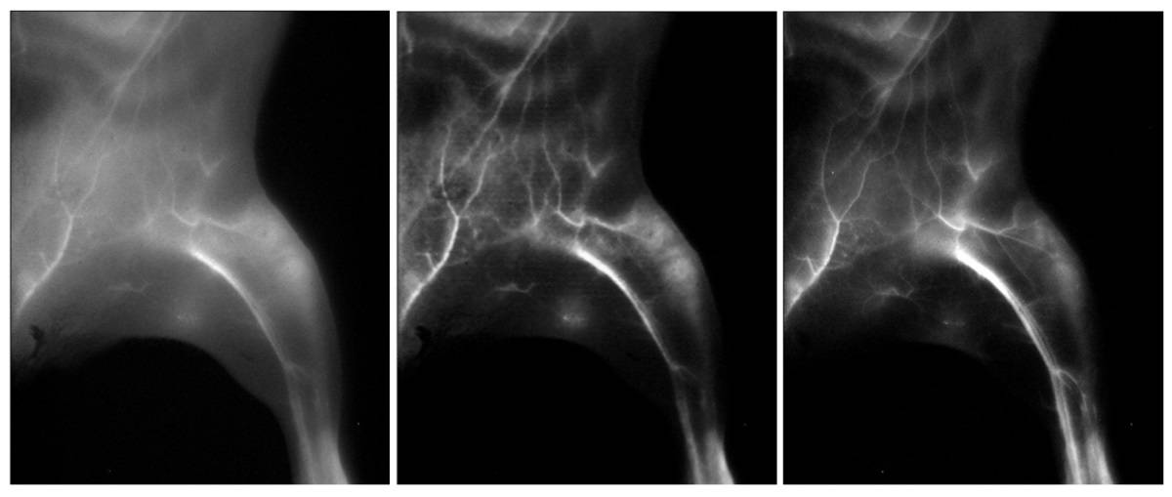
- Computer-controlled XYZ positioning for positioning the needle over the selected target.
- Controlled needle insertion and simulated blood extraction using actuators and a syringe/pumping mechanism.
- Safety monitoring using force sensing, position limits, emergency-stop mechanisms, and software restrictions.
Unlike a simple vein-finding device, the proposed system attempts to create an end-to-end research platform that progresses from vein detection → target selection → robotic positioning → simulated insertion → fluid extraction.
The project will initially focus on a vascular phantom rather than human testing. This allows the vision, robotics, control, and fluid-handling technologies to be developed and evaluated without exposing patients to the risks associated with experimental needle insertion.

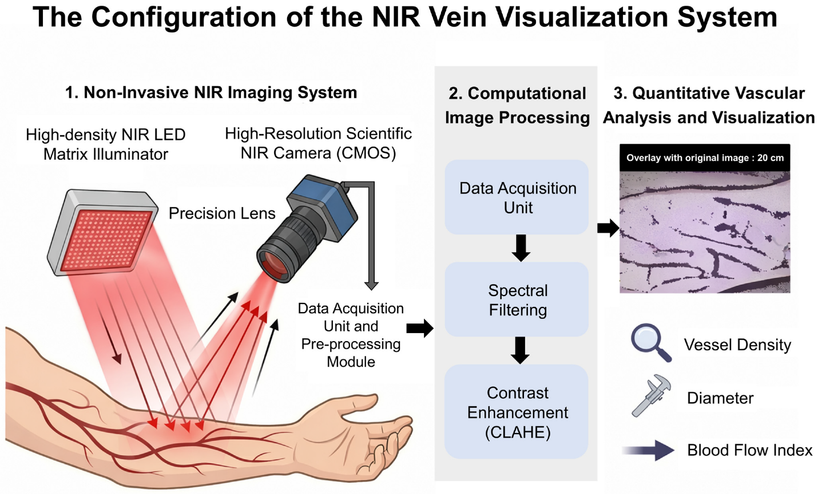

4. Component List

Hardware Components
Category | Components
Processing | Raspberry Pi 5 / NVIDIA Jetson Orin Nano
Microcontroller | ESP32 / STM32
Imaging | NoIR/NIR camera
Illumination | 850 nm or 940 nm IR LED array
Motion | NEMA 17 stepper motors
Motor Drivers | TMC2209 stepper motor drivers
Mechanical Motion | Linear rails, lead screws, couplers, bearings
Position Feedback | Limit switches, rotary/linear encoders
Force Measurement | Load cell + HX711 / force sensor
Fluid System | Peristaltic pump or syringe pump
Fluid Reservoir | Syringe/reservoir
Tubing | Flexible medical-grade or laboratory tubing
Artificial Arm | Silicone vascular phantom/ Silicone vascular phantom
Vascular Network | Embedded flexible tubing
Fluid | Water/glycerin mixture with suitable dye
Safety | Emergency-stop switch
Power | DC power supply, voltage regulators, fuses
Fabrication | 3D-printed mechanical components and mounting brackets

Software Components
- Python
- C/C++
- OpenCV
- NumPy
- PyTorch (optional, for AI-based vessel segmentation)
- ROS 2
- Arduino IDE / PlatformIO
- ESP-IDF, if ESP32 is used
- CAD software such as Fusion 360 or SolidWorks
- Git/GitHub for version control
- Data logging and visualization software

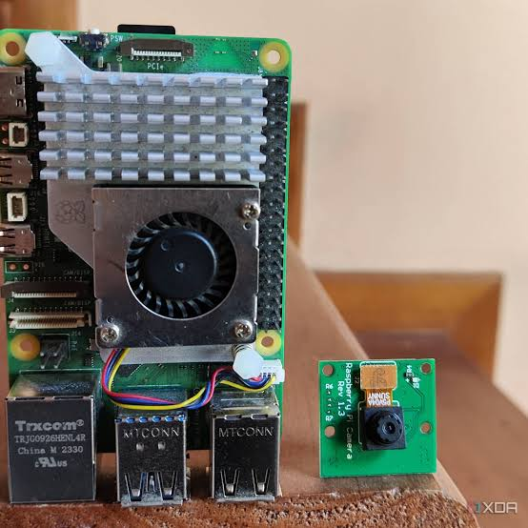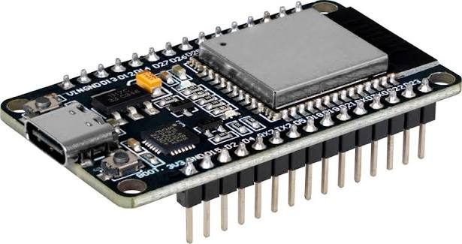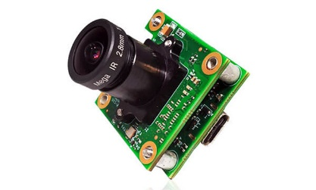

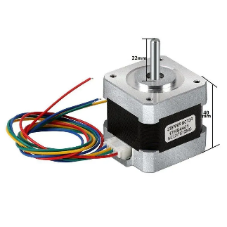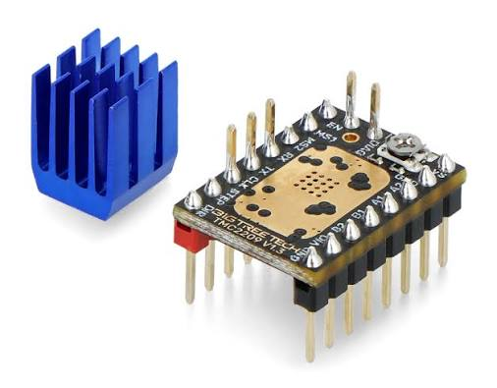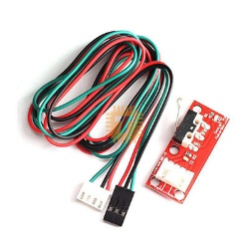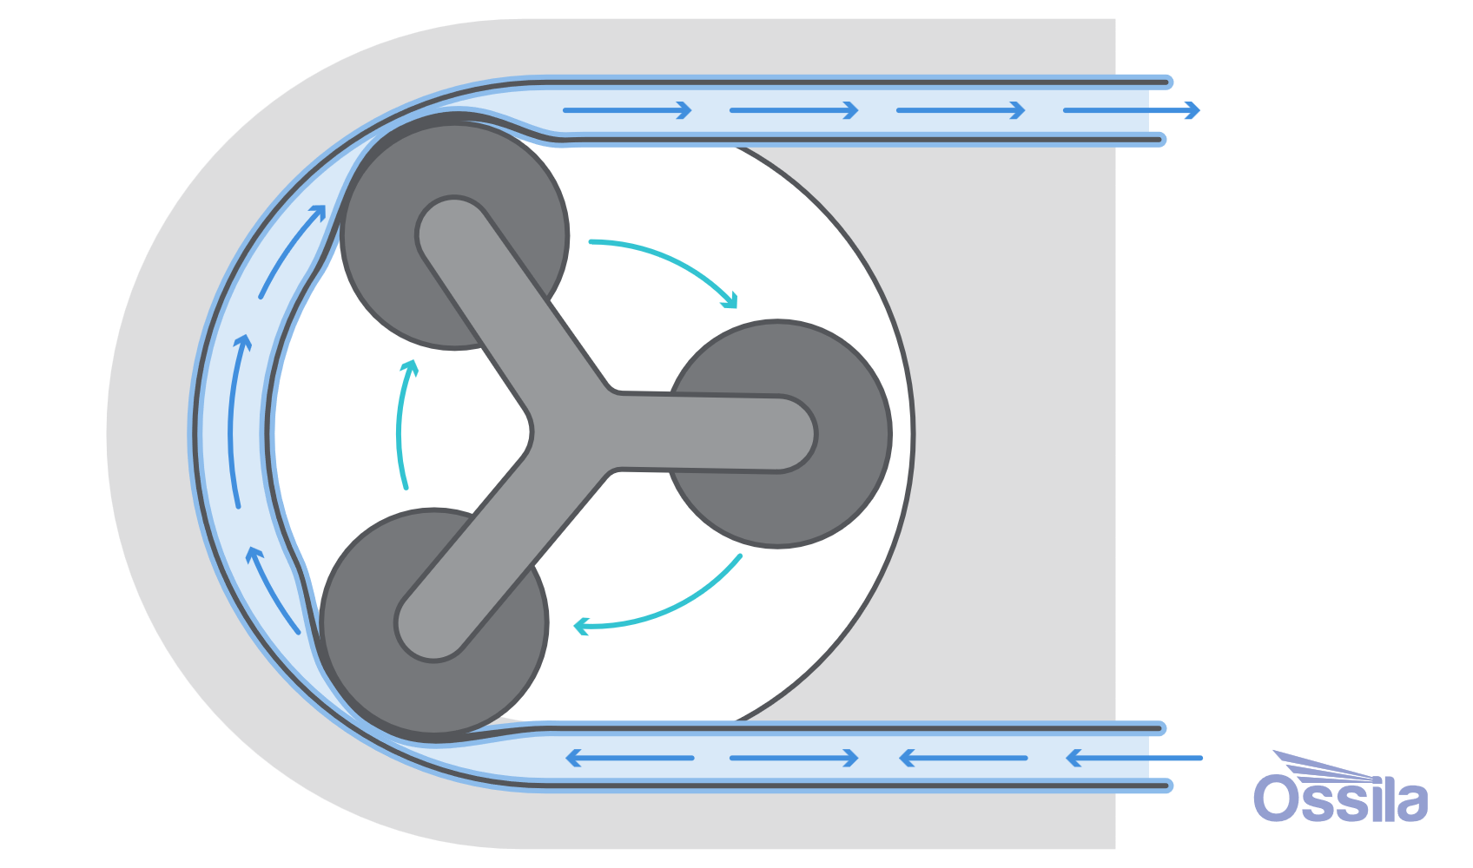

5. Features

Feature 1 — Automated Vein Detection
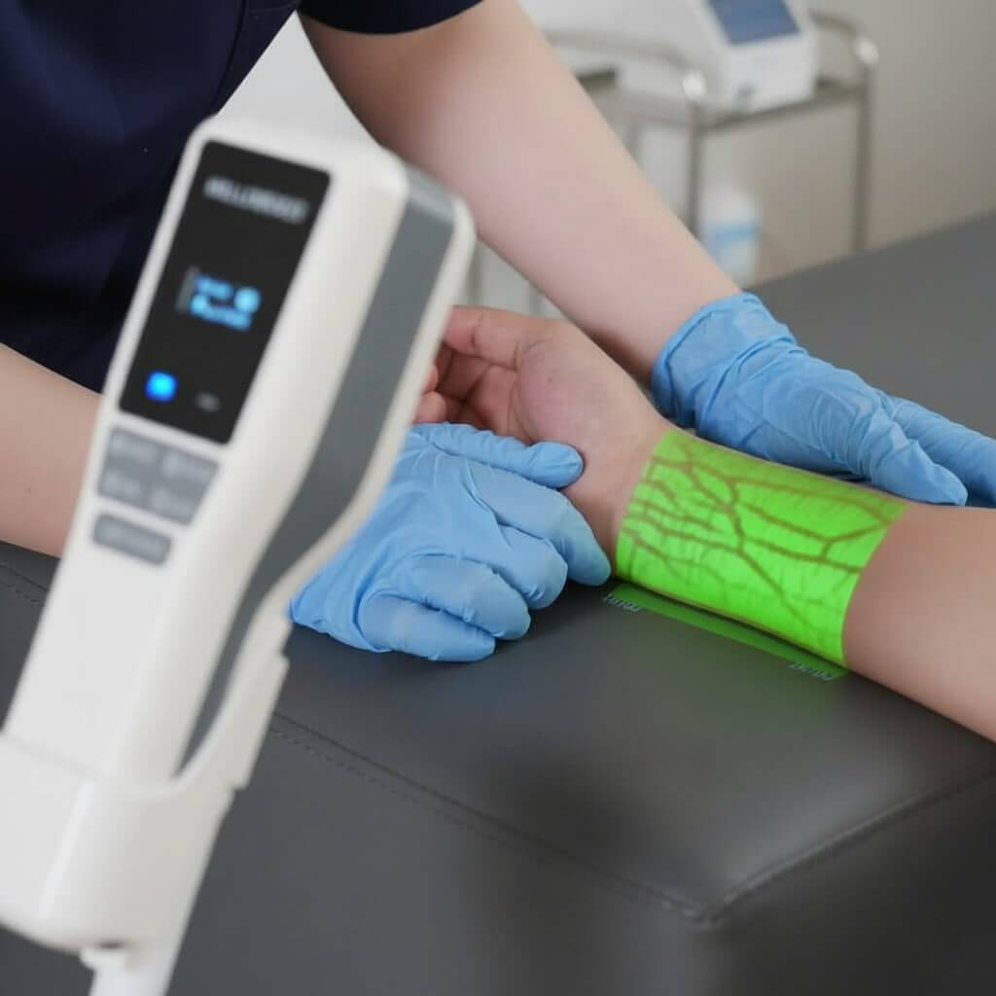
Information:
The NIR camera captures images of the prosthetic arm while the embedded vascular tubes carry dyed fluid. The system receives image frames containing information about the position, shape, and apparent path of the artificial veins.
Decision:
The processing computer applies image-processing techniques such as grayscale conversion, noise reduction, contrast enhancement, thresholding, morphological processing, and vessel segmentation. The system determines which regions of the image correspond to potential veins and extracts their centerlines.
Action and Solution:
The detected vessel paths are converted into coordinates relative to the robotic positioning system. These coordinates are passed to the target-selection module, allowing the robot to determine where the needle should be positioned.
Component Interaction:
The NIR LED array illuminates the arm. The NoIR camera captures the resulting image and sends it to the Raspberry Pi or Jetson. OpenCV processes the image and extracts the artificial vessel network. The computer then sends the detected vessel coordinates to the control system.

Feature 2 — Optimal Injection Site Selection
Information:
The system receives information about the detected vessel’s location, apparent diameter, orientation, straightness, accessibility, and distance from the arm surface.
Decision:
The target-selection algorithm evaluates multiple points along the detected vessels. Each candidate point is assigned a suitability score based on predefined criteria, such as adequate vessel diameter, sufficient straight vessel length, appropriate insertion geometry, and accessibility.
Action and Solution:
The system selects the highest-scoring location as the target point and calculates the required position and orientation of the robotic needle mechanism.
Component Interaction:
The computer-vision module supplies vessel coordinates to the target-selection algorithm. The algorithm evaluates candidate locations and produces a target coordinate. The coordinate is then converted into the robot’s coordinate system and transmitted to the ESP32/STM32 motion controller.

Feature 3 — Automated Needle Positioning
Information:
The motion controller receives the selected target coordinates from the high-level computer. Position feedback is obtained from limit switches and, where available, encoders.
Decision:
The controller calculates the required movement along the X, Y, and Z axes and determines whether the target position can be reached within predefined mechanical limits.
Action and Solution:
The stepper motors move the needle assembly along the corresponding axes until the needle reaches the calculated target position. The system stops movement when the target coordinates are reached or when a safety limit is triggered.
Component Interaction:
The Raspberry Pi/Jetson sends target coordinates to the ESP32/STM32. The microcontroller generates motion commands for the TMC2209 drivers. The drivers control the NEMA 17 stepper motors, which move the needle mechanism through the linear rails and lead screws. Limit switches and encoders provide feedback to prevent movement beyond safe mechanical boundaries.

Feature 4 — Controlled Needle Insertion
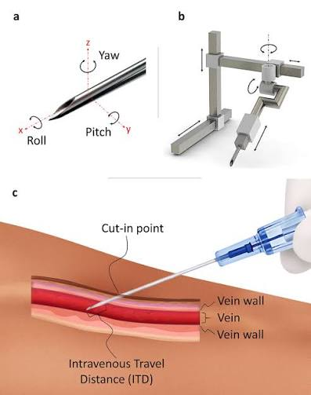
Information:
The system receives the target position and force information from the robotic positioning system and force sensor.
Decision:
The controller checks whether the needle is correctly positioned and whether the measured insertion force remains within predefined limits. If excessive force or an unexpected mechanical condition is detected, insertion is immediately stopped or retracted.
Action and Solution:
If all conditions are satisfied, a linear actuator advances the needle a controlled distance into the artificial tissue until the predetermined insertion depth is reached. The system then stops the actuator.
Component Interaction:
The positioning system aligns the needle with the selected vessel. A force sensor monitors mechanical interaction between the needle assembly and artificial tissue. The ESP32/STM32 continuously evaluates the sensor signal and controls the insertion actuator. Mechanical depth limits and software limits provide additional protection.

Feature 5 — Automated Simulated Blood Extraction
Information:
After successful simulated vessel access, the system receives the state of the insertion mechanism and fluid-flow information.
Decision:
The controller verifies that the needle is positioned at the target and that the system has not detected excessive force, abnormal movement, or another fault condition.
Action and Solution:
The syringe pump or extraction mechanism activates and draws the dyed fluid from the artificial vessel into a collection reservoir, simulating a blood-draw procedure.
Component Interaction:
The microcontroller activates the syringe pump after receiving confirmation from the positioning and safety systems. The pump creates controlled negative pressure and draws the dyed fluid through the needle and tubing. The extracted fluid is collected in a reservoir, allowing the success of the simulated blood draw to be measured.

Feature 6 — Safety and Emergency Shutdown
Information:
The safety system continuously receives information from the emergency-stop switch, force sensor, limit switches, motor status, and software watchdog.
Decision:
The controller checks whether any predefined unsafe condition has occurred, such as excessive force, movement beyond a mechanical limit, communication failure, actuator malfunction, or manual emergency-stop activation.
Action and Solution:
If an unsafe condition is detected, the system immediately disables the relevant motor/actuator outputs and places the robot into a safe state. The needle mechanism can also be designed with a passive mechanical retraction mechanism.
Component Interaction:
Safety sensors communicate with the real-time microcontroller independently of the high-level computer wherever possible. The emergency-stop circuit should be capable of disabling actuator power without relying solely on software. The ESP32/STM32 monitors the remaining safety signals and prevents further movement whenever a fault condition is detected.

Overall System Interaction
The complete system operates as a pipeline:
Artificial Arm → NIR Imaging → Vein Detection → Target Selection → Coordinate Transformation → Robotic Positioning → Safety Verification → Controlled Insertion → Simulated Blood Extraction
The high-level computer is responsible for computationally intensive operations such as image processing, vessel detection, target selection, and system-level decision making. The microcontroller is responsible for time-critical functions such as motor control, sensor monitoring, limit detection, and emergency responses.
This separation creates a safer and more modular architecture: the computer determines where the robot should move, while the real-time controller determines how the physical hardware moves and whether movement remains safe.
The initial prototype should remain restricted to an artificial vascular phantom containing dyed fluid. Any transition toward human testing would require substantially more work involving medical validation, risk management, appropriate clinical supervision, regulatory requirements, and extensive safety testing.

